University of Technology Sydney

31260 Interface Design

Assignment 3

Interface Development and Implementation

Authors:

Chi Kit Chan (ID 11301506)

Ka Hei Chan (ID 11301239)

Table of contents

Goal 2

Scenario 3

User story 3

Design rationale 3

Heuristic evaluations of prototype 1 3

Test methodology 3

Findings 4

1. Duplication close function in notification windows 4

2. “>>” to read more in news preview is misleading 4

3. Missing system feedback in news following 4

4. Catalogue function misplacing 4

5. Popup notification has no preview 4

6. No followed history 4

Design of the second prototype 5

Conclusion 5

Appendix 6

Screenshot of first prototype 6

Screenshot of second prototype 11

Evaluation evidence 11

Sketch of prototype 12

# Goal

The selected goal of the design is “Catching up on news from around the world”.

# Scenario

It is in the year 2024 on a Monday morning in Sydney, Tex is on his way to his workplace as usual. Tex’ office is situated far away from his home. It takes a long time to travel. Tex would like to use the travelling time to read the latest news. He is particularly interested in world affairs and sport news. Currently it is during NBA season, Tex is a fan of the basketball team Chicago Bulls so he would like to catch up news about their latest matches and events. Besides the tension of Cold War 2 is growing, Tex is very worried about the situation.

# User story

Tex wants to read and follow interesting news highlights from around the world while on his way to work.

# Design rationale

The design project is to design and produce a high fidelity prototype of the application for Tex to achieve the goal.

The high-fidelity prototype started by following the sketch of screens from the previous paper prototype design (see appendix). Also taking considerations from the previous evaluations of the paper prototype. However, due to technical constraints, some feature couldn’t be implemented, such as the news category filter dropdown list, as well as different appearance than the paper prototype. As a result, the high-fidelity prototype mostly follow the original design, but with some minor adjustments. Screenshots of the prototype is attached in appendix.

The design uses web technology such as HTML, CSS, JavaScript to build a set of web pages that mimic a mobile phone and the application. The starting point of the prototype is “home.html” file.

The design uses standard elements such as navigation bar, home button, menu buttons, back button, as well as the common icon set. The buttons and hyper links are styled following common design, such as blue text for links, rounded 3D buttons. Page title is displayed on top in a title bar. Therefore, most users should be able to know how to navigate through the application.

The World map for displaying world news uses an interactive real world map. It allows user to zoom in or out, pan in every direction. News highlights image thumbnails are displayed as bubbles on the map pinned to the right location on the map. The design allows users to view news from around the world, and have a clear idea where they take place easily.

# Heuristic evaluations of prototype 1

## Test methodology

Several user evaluations were carried out to help to evaluate the prototype. One user was invited to participate in the test. Wizard of Oz technique is used, where the user will be shown the prototype and invited to interaction with the system to perform the task. User’s actions and opinions were recorded and then Nielson’s Heuristics is applied to evaluate the prototype.

## Findings

### 1. Duplication close function in notification windows

minimalist design

### 2. “>>” to read more in news preview is misleading

User does not notice >> represents the link to the news page.

“Read more” is instead of >> for better leading.

### 3. Missing system feedback in news following

### 4. Catalogue function misplacing

### 5. Popup notification has no preview

### 6. No followed history

7. The interface is not fully updated after sport news is selected

Only the world map has been updated but headings and news highlight still remain as world news

2nd Version : the headings and news highlight are updated to sport related.

# Design of the second prototype

The second prototype is made to resolve usability issues addressed in the user evaluation. Below is a list of the changes

# Conclusion

The outcome of this project is the high fidelity prototype of the design of the newsreader application for Tex to archive the goal of reading news from around the world.

The biggest feature of the design we think is the world map interface to display news headlines form around the world and allow users to interact with it in a very intuitive way. And also the ability to project article using mobile projector to provide a bigger “screen” for users to read news, this should allow Tex to read much more easier.

# Appendix

## Screenshot of first prototype

|  |  |
| --- | --- |
| E:\UTS\Github\interfacedesign-prototype\doc\phonehome.PNGOS Home screen | App home screenE:\UTS\Github\interfacedesign-prototype\doc\home.PNG |
|  |  |
|  |  |
|  |  |
|  |  |
| E:\UTS\Github\interfacedesign-prototype\doc\usvschina.PNG |  |
|  | E:\UTS\Github\interfacedesign-prototype\doc\mjpredie.PNG |
|  |  |
| E:\UTS\Github\interfacedesign-prototype\doc\mjdie.PNG |  |

## Screenshot of second prototype

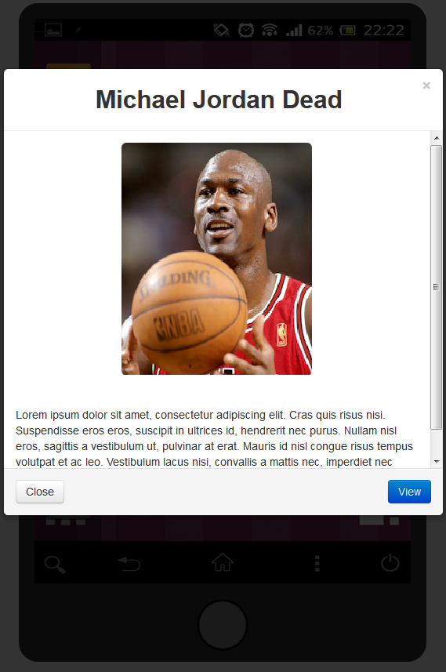

## 

## Evaluation evidence

## Macintosh HD:Users:nelson:Documents:Academics:UTS:2013-autumn:31260 Interface Design:assign2:Prototype:sketch-eval:DSC_0352.jpgSketch of original prototype